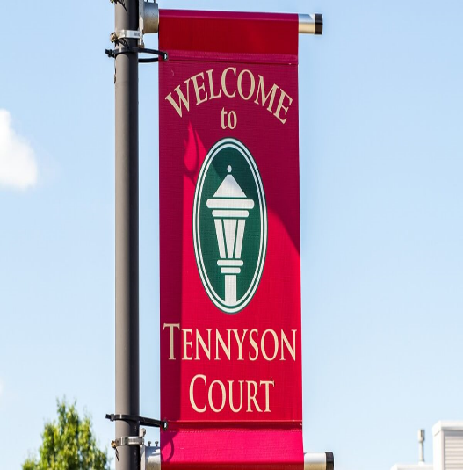
~ Welcome to Tennyson Court ~
There are so many things to consider when making a move. Our dedicated team at
Tennyson want to make the transition hassle free and as comfortable as possible.
During the move, we encourage you to ask questions as they arise.

Here is a helpful checklist of items to complete:
Paperwork needed prior to move in:
- Tennyson Court Application
- Medical Evaluation (DSS 3122) needs to be completed and signed by the Primary Care Physician. Your loved one
must be seen within 30 days of admission. (If coming from a rehab or hospital this form will be provided to us)
- Copy of Power of Attorney
- Copy of Health Care Proxy
- Copy of all Insurance cards (medical and prescription), and their Social Security Card
- $2,500 Community Fee
- Pre-admission screen evaluation completed by our Case Manager
Prior to Move-In (Miscellaneous):
- If you desire phone service, please call Spectrum to set up a phone line #1-866-668-6044
- Notify the Post Office of Change of Address ~ 49 Tennyson Court, Williamsville, NY 14221
Day of the Move:
- If bringing medications from home; please ensure that they are in their original pill bottle containers
- We will complete and sign the Admission Agreement
- Family to meet with our Resident Care Director and Nurse Case Manager to review care plan
- Payment due (prorated current month) and bill provided to representative for following month
- Complimentary lunch for 4 guests to join their loved one on admission day

Our rooms come furnished with a bed, bedding, nightstand, lamp, dresser and flat screen television (mounted to the wall). Feel free to use our furniture or you can mix and match with your own. We always encourage families to bring decorations and pictures to personalize the room, and our staff are always available to help during this process.

Don’t Forget:
Clothing, Bathrobe, Pajamas, Undergarments, Slippers, Supportive Shoes, Plastic Hangers, Shampoo, Conditioner,
Body Wash, Soap, Lotion, Comb, Brush, Toothpaste, Toothbrush, Kleenex, etc.

Items to Avoid in our Community:
Wall plug-in deodorizers, Candles, Coffee Pots, Keurig machines, outlet adaptors, electric blanket, heating pad, etc.
(Anything that poses a fire hazard in a resident room is prohibited by the New York State Department of Health)

If you have any questions during this time, please call Sue Nawojski in the Admissions office at (716)632-9496

